Homework activities are intended to be as open ended as possible, allowing the children to reflect on their learning in class in a creative way
and for the children to make their own decisions on how to collect, record and present their home learning.

Each week your child will be expected to complete a homework grid task. They can answer the question or complete the task in their own
preferred way on one or two pages in their homework book. Here are some ideas of how children might
approach learning grid activities:
Termly Reminders
- PE days are Monday and Wednesday.
- Please ensure children have a named water bottle in school.
- We encourage children to read for at least 10 minutes each day from home.
- Children must complete their homework task each week.

● Drawing, colouring, sketches, labelled diagrams, artwork- painting, collage, 3D constructions
● Cooking with photographs or explanations
● Take photographs or even videos of their work
● Use the internet as a resource
● Tables, charts and grids
● Writing fiction, poems, descriptions
● Writing non-fiction-report, diary, letter, journal, newspaper report, e mail, leaflet, debate or explanation
● Invitations, postcard
● Your child can include objects or resources or references to them.

We hope you have fun learning

Option 1 – Viking Saga  The Vikings used to tell long adventure stories called sagas  Write your own Viking saga. An exciting story of adventure, battle or love perhaps? | 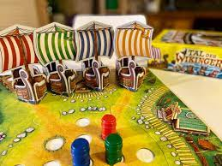  Option 2 – Design a Viking board game  Design a Viking board game. How many players can play? What is the purpose of the game and how do you win? | Option 3 - Viking collage  Think about an interesting Viking scene – here are some ideas to help you:  - A longboat on a stormy sea  - A Viking farm  - The rainbow bridge between Midgard and Asgard  - A Viking raid!
Option 4 – Viking Gods  Research then draw or paint a picture of a Viking God.  Annotate your picture with key/interesting facts about your chosen God. | Option 5 – A longhouse model  Research the features of a longhouse (the fire in the middle, a thatched roof, benches with animal skins) and try to create a miniature version. Choose your materials carefully! | 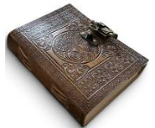  Write a diary entry for a Viking warrior or an Anglo-Saxon settler. How would a diary entry be written long ago?  Option 6 – Dear Diary
Option 7 – Recipe for a raid  You will need:  - 20 angry Vikings  - 1 longboat  - 1 monastery  - Several peaceful Anglo-Saxon monks  Can you write your own ‘Recipe for a Raid’?  Option 7 – Design | Option 8– Hungry Work  Create a Viking feast. Research, prepare and cook a typical Viking meal.  What did they eat and drink from? Can you design your own eating utensils to make the feast as authentic as possible? | Option 9 – Freedom!  Choose your own Viking themed activity.  

