ENGLISH

- Read most unfamiliar words and predict the meaning of related words using prior knowledge.
- Identify and retrieve relevant points and key ideas from different points in a text.
- Compare and contrast the styles of different writers.
- Identify the ways in which one paragraph is linked to the next.
- Take part in discussions, taking account of what others say.
- Understand the motives of characters.
- Refer to the text to support predictions and provide examples.
- Use further prefixes and suffixes.
- Spell many words with silent letters.
- Distinguish between more complex homophones. Select appropriate forms of writing after identifying the audience and purpose of the writing.
- Draft and write by selecting appropriate grammar.
- Understand how the passive affects the presentation of information. Identify how an author uses bullet points within a text.

ART
Drawing and Sketching
- Artist: Stephen Wiltshire
- Architect: Antoni Gaudi
- Outcome: Viewfinder sketches of a Mayan temple
P.E.
- Rounders
- Orienteering

Knowledge: Know that taught skills and strategies are transferable and can be applied to a variety of different sports.

MUSIC
How do we write our own music?
- Improvise and compose music for a range of purposes using the inter-related dimensions of music

FRENCH
- I can prepare and practise a simple conversation, reusing familiar vocabulary and structures in new context
- I can listen attentively and understand more complex phrases and sentences
- I can make simple sentences and short texts

Classification connoisseurs

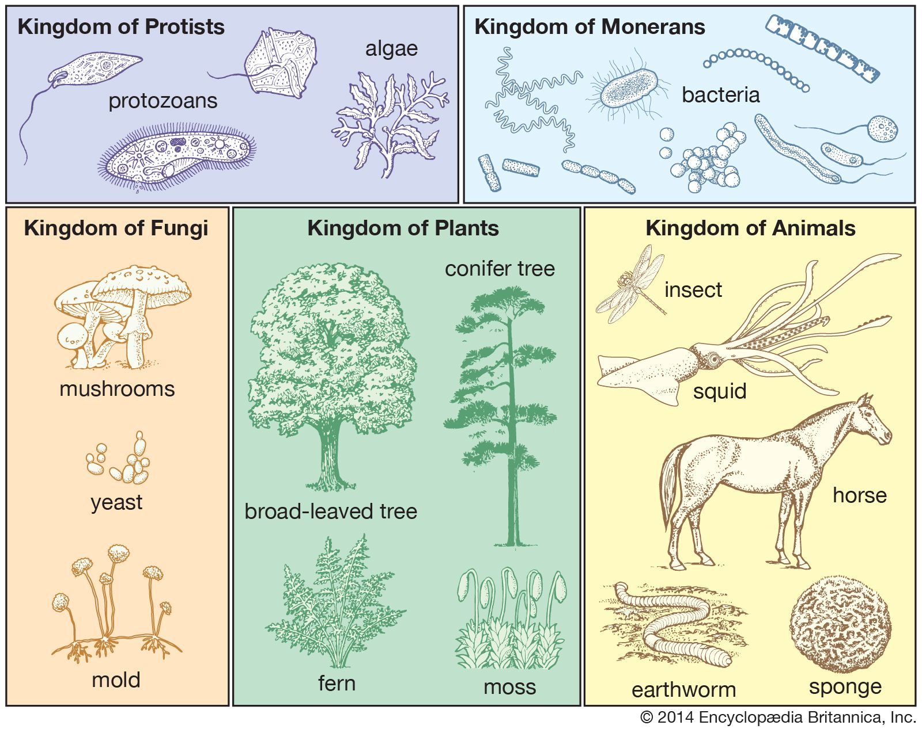
Term 5 - Year 5 and 6
MATHS
Fractions, Decimals and Percentages
- Equivalent fractions and decimals - tenths
- Equivalent fractions and decimals - hundredths
- Equivalent fractions and decimals - thousandths
- Fractions as division
- Understand percentages
- Percentages as fractions
- Percentages as decimals
- Equivalent F, D, P
- Order F, D, P
- Percentages of an amount

Ratio
- Add or multiply?
- Use ratio language
- Ratio and fractions
- Use scale factors
- Similar shapes
- Ratio problems
- Proportion problems

Algebra
- Function machines
- Form expressions
- Substitution
- Formulae
- Form equations
- Solve equations
- Find pairs of values
- Solve problems with two unknowns

Shape
- Understand and use degrees
- Classify angles (include estimate)
- Measure angles (include estimate)
- Calculate angles around a point
- Calculate angles on a straight line
- Vertically opposite angles

SCIENCE – Living things and their habitats
- To give examples of animals in the five vertebrate groups and some of the invertebrate groups.
- To give the key characteristics of the five vertebrate groups and some invertebrate groups.
- To compare the characteristics of animals in different groups.
- To give examples of flowering and nonflowering plants.
- To use classification materials to identify unknown plants and animals.
COMPUTING
- PowerPoint skills and presentation.
- Online safety.
- File saving and retrieval.

HISTORY
What did people do to survive The Blitz in World War II?

- To recall and sequence the events leading up to the Blitz
- Know how different people around the world were affected by the war
- To know what it was like to be an evacuee in WW2 using historical sources
- To know the roles of women during the war and how the efforts and responsibilities of women during the war were so important

Knowledge:
Explain reasons why the Blitz was of particular significance to World War 11
COMPUTING
Variables in Games
- I can understand variables
- I can use variables in programming
- I can improve a game
- I can understand what it means to become a games designer
- I can design to code
- I can evaluate and improve on a game design
RE: Christianity
- What would Jesus do?
PSHE
- What affects mental health and ways to take care of it; managing change, loss and bereavement; managing time online
- Human reproduction and birth; increasing independence; managing transition

WWO: Trust
- Knowing and using names.
- Eye contact
- Random Grouping

