I like reading and writing | Ask a grown up what their favourite book was as a child and read it with them! Share your own favourite book and talk about why you both like them. Write a couple of sentences to tell me about the books. | Create a fact sheet all about you. What is your favourite colour? What is your favourite food? What is your favourite song? Etc.  Do you have a special talent? We’d love to hear all about it.
I enjoy maths | Go on a number hunt. You could look in books and magazines, on door numbers, number plates, clocks, price labels, remote controls, phones, calendars or greetings cards. Talk about the numbers you see and record your findings by drawing pictures or taking photos of the numbers you find. |  |  | Make your own number line. You can use items to show the numbers in order in words and pictures and either draw, write or photograph your very own number line
I like researching and finding things out. |   Find out what people do in the different seasons and make a poster or book of the different seasons using what you have found out |  | Ask some members of your family what school was like for them?  Draw or make a model of what it was like then or what you think it looks like now
I like to make things and be creative. | Create something of your own choosing from story of the Enormous Crocodile e.g model, book, poster, poem e.t.c. Be creative!  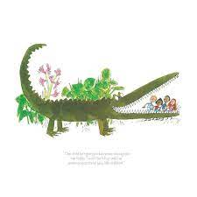
I like to draw and paint. | Look at the work of Yayoi Kusama. create your own pattern using any media of your choice.  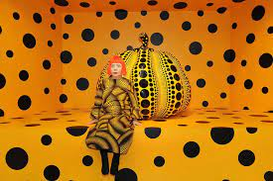
Wildcard! | Come up with your own homework and explain to the class what you have done and tell us WHY you chose to do what you did!
Please bring in home learning each week, to be shared in class every Friday.
Year 1 and 2 Homework Grid – Always Dare to Dream Term 1 2025 Each week you should: complete a quality piece of homework from the grid below, read regularly to an adult and practise key instant recall number facts (little and often is best).

