**MUSIC**

* Explore the foundational elements of music; pulse, tempo, rhythm, dynamics, pitch
* Prepare for Christmas performances.

**MATHS**

**Number – Addition and Subtraction**

* Solve problems, including missing number problems, using number facts, place value, and more complex addition and subtraction.
* Solve addition and subtraction two-step problems in contexts, deciding which operations and methods to use and why.

**Number - Multiplication and Division**

* Count from 0 in multiples of 4 and 8 Count in multiples of 6, 7 and 9
* Recall and use multiplication and division facts for the 3, 4 and 8 multiplication tables.
* Recall and use multiplication and division facts for multiplication tables up to 12 × 12.
* Write and calculate mathematical statements for multiplication and division using the multiplication tables they know, including for two-digit numbers times one-digit numbers, using mental and progressing to formal written methods.
* Use place value, known and derived facts to multiply and divide mentally, including multiplying by 0 and 1; dividing by 1; multiplying together three numbers.
* Solve problems, including missing number problems, involving multiplication and division.
* Solve problems involving multiplying and adding.
* Recognise and use factor pairs and commutativity in mental calculations.

**FRENCH**

* Recognise, recall and remember the 4 seasons in French.
* Recognise, recall and remember a short phrase for each season in French.
* Say which season is their favourite in French and attempt to say why using the conjunctions ‘et’ and ‘car’.

**RE: Hinduism**

* What do Hindus believe God is like?

**PSHE – Relationships**

* Respecting ourselves and others
* Family and Friendships

**COMPUTING - Animation**

* I can create an effective stop frame animation.
* I can create a storyboard.
* I can add other media to my animation.

**PE**

* Hockey - What skills/knowledge do we need to play a basic game of hockey?
* Dance - Is dance all we need to create a performance?

**WWO: Trust**

* Taking turns
* Random Grouping

**HISTORY**

* Recall when the Stone/Bronze and Iron age civilisations existed in relation to other significant ages and the modern age and how these periods changed over time.
* Identify some of the effects of the Neolithic Revolution
* Explain how achievements in each age helped develop the next age
* Identify how each age built on from the last
* Describe how society changed gradually over a long period of time
* Describe how housing changed between the Stone and Bronze Age significantly but not as much between the Bronze and Iron Age
* Describe how settlements and beliefs change from the Stone Age to the Iron Age

**SCIENCE – Rocks and Soils**

* Compare and group together different kinds of rocks based on their appearance and simple physical properties.
* Describe in simple terms how fossils are formed when things that have lived are trapped within rock.
* Recognise that soils are made from rocks and organic matter.

**Footsteps Through Time**

Term 2 - Year 3 and 4

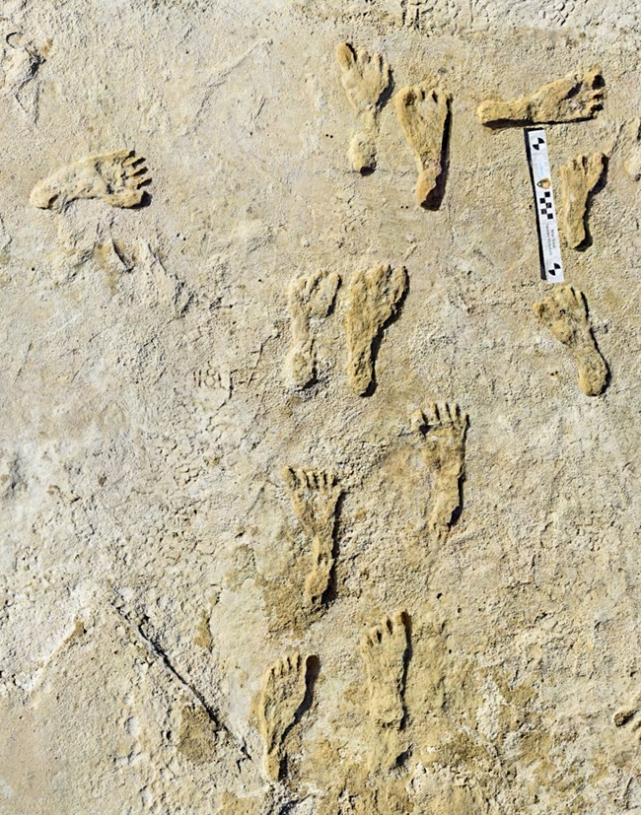

**DT**

* Learn about how a variety of ingredients are grown, reared, caught and processed
* Review dishes and use as a means to plan own dish and suggest improvements.
* Learn the importance of hygiene practices when handling food
* Select and use a range of utensils.
* Select and using a range of healthy ingredients
* Review work against own design criteria

**ENGLISH**

* Predict what might happen by quoting directly from the text.
* Infer meaning, using evidence from the text and wider experiences.
* Talk about the author’s choice of language and its effect on the reader in a range of texts.
* Explore potential meaning of ambitious vocabulary read in context.
* Summarise and explain the main points in a text.
* Use knowledge of text structure to locate information.
* Explain how and why main characters act in certain ways in a story.
* Identify the main clauses in sentences I have written.
* Use inverted commas in direct speech.
* Recognise some differences between different poems.
* Understand and discuss how different tone and volume affects the meaning of my reading.
* Explore and discuss how the use of language varies for audiences and purposes.
* Recognise key themes in what I have read.
* Proofread my work to check for spelling, grammar and punctuation errors.
* Use a dictionary to check the meaning of new words.
* Create settings, characters and plot in narrative writing.
* Express time, place and cause using conjunctions.
* Propose changes to grammar and vocabulary to improve consistency including the accuracy of pronouns.