ENGLISH
Read between the lines, using clues from action, dialogue and description to interpret meaning and/or explain what characters are thinking/feeling and the way they act.
Refer to the text to support opinions and predictions.
Infer and deduce meaning based on evidence drawn from different points in the text.
Explore different voices in our reading.
Use pronouns appropriately to avoid repeating the noun.
Ask questions and respond appropriately within group discussions making relevant comments to the suggestions of others.
Consider with some understanding different arguments and viewpoints responding to them.
Talk about a genre of writing identifying structure, vocabulary and grammar.
Compose and rehearse sentences orally, improving them through a range of varied and rich vocabulary and range of sentence structures.
Organise our writing in paragraphs around a theme.
Discuss and record our ideas to support our understanding of writing in a variety of different genres.
Assess the effectiveness of our own and others' writing.
Proofread work to check for spelling, grammar and punctuation errors.
Use the diagonal and horizontal strokes that are needed to join letters.

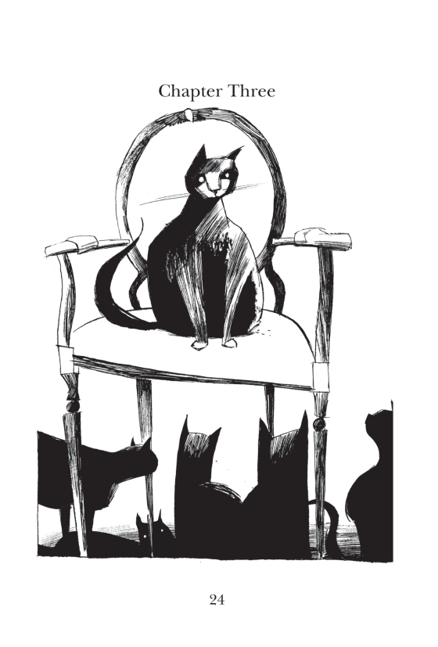

Belonging to a Community
How does the Earth shake, rattle and roll?

Term 3 2026 - Year 3 and 4

MATHS
Number – Multiplication and Division
Write and calculate mathematical statements for multiplication and division using the multiplication tables they know, including for two digit numbers times one-digit numbers, using mental and progressing to formal written methods.
Multiply two digit and three digit numbers by a one-digit number using formal written layout.
Solve problems involving multiplication and addition, including missing number problems, involving multiplication and division, including positive integer scaling problems and correspondence problems.
Recognise and use factor pairs and commutativity in mental calculations.
Measurement - Length, Perimeter and Area
Measure, compare, add and subtract: lengths (m/cm/mm).
Measure the perimeter of simple 2D shapes. Measure and calculate the perimeter of a rectilinear figure (including squares) in centimetres and metres
Continue to measure using the appropriate tools and units, progressing to using a wider range of measures, including comparing and using mixed and simple equivalents of mixed units.
Convert between different units of measure eg kilometre to metre.
Find the area of rectilinear shapes by counting squares

Computing - Creating Media:
Identify that sound can be recorded.
Explain that audio recordings can be edited.
Recognise the different parts of creating a podcast project.
Apply audio editing skills independently.
Combine audio to enhance my podcast project.
Evaluate the effective use of audio.
SCIENCE – Rocks and Soils continued.
Describe in simple terms how fossils are formed when things that have lived are trapped within rock.
Recognise that soils are made from rocks and organic matter.

RE - Hinduism - What does it mean to be Hindu in Britain today?
Describe how Hindus show their faith within their families and within their wider communities.
Understand and identify different ways in which Hindus show their faith
Reflect on what this means for individuals and for wider society.

Geography
Describe and understand key aspects of physical geography, including: volcanoes and earthquakes.
Use maps, atlases, globes and digital/computer mapping to locate countries and describe features studied.

