ENGLISH
Read between the lines, using clues from action, dialogue and description to interpret meaning and/or explain what characters are thinking/feeling and the way they act.
Skim and scan to identify key ideas and answer questions from a text.
Create settings, characters and plot in narrative writing.
Ask questions and respond appropriately within group discussions making relevant comments to the suggestions of others.
Compose and rehearse sentences, improving them through a range of varied and rich vocabulary and range of sentence structures.
Explain how and why main characters act in certain ways in a story, using evidence from the text.
Talk about a genre of writing identifying structure, vocabulary and grammar.
Compose and rehearse sentences orally, improving them through a range of varied and rich vocabulary and range of sentence structures.
Talk about the effects of different words and phrases to create different images and atmosphere.
Comment on the author's choice of language to create mood and build tension.
Use selected adjectives to create variety and add impact.
Use a comma to mark a pause in a complex sentence.
Express time, place and cause using prepositions.
Choose specific nouns and powerful verbs depending on the purpose of my writing.
Proofread work to check for spelling, grammar and punctuation errors.
Use the diagonal and horizontal strokes that are needed to join letters.

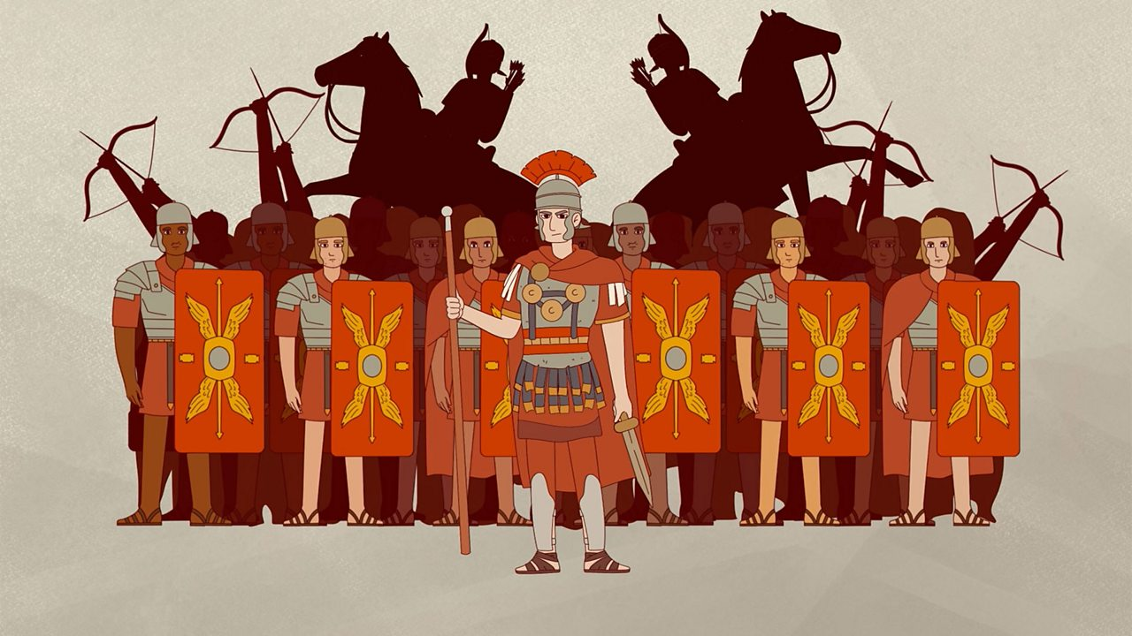

Romans Rule!
Why were the Romans so powerful?

Term 4 - Year 3 and 4

MATHS
Fractions and Decimals
Recognise and use fractions as numbers: unit fractions and non-unit fractions with small denominators.
Recognise, find and write fractions of a discrete set of objects: unit fractions and non-unit fractions with small denominators.
Solve problems involving increasingly harder fractions to calculate quantities, and fractions to divide quantities, including non-unit fractions where the answer is a whole number.
Count up and down in tenths; recognise that tenths arise from dividing an object into 10 equal parts and in dividing one-digit numbers or quantities by 10 Count up and down in hundredths; recognise that hundredths arise when dividing an object by one hundred and dividing tenths by ten.
Recognise and show, using diagrams, equivalent fractions with small denominators. Recognise and show, using diagrams, families of common equivalent fractions.
Add and subtract fractions with the same denominator within one whole. Add and subtract fractions with the same denominator. (Y3)
Recognise and write decimal equivalents of any number of tenths or hundredths. (Y4)
Round decimals with one decimal place to the nearest whole number. (Y4)
Compare numbers with the same number of decimal places up to two decimal places. (Y4)

SCIENCE – Living Things and their Habitats
Recognise that living things can be grouped in a variety of ways.
Explore and use classification keys to help group, identify and name a variety of living things in their local and wider environment.
Recognise that environments can change and that this can sometimes pose dangers to living things.

RE: Christianity
Why Do Christians Call the Day Jesus Died ‘Good Friday’?
Explain the concept of salvation and what this means for Christians.
Make links between the Gospel accounts and aspects of the Easter celebrations.
Reflect on why the day Jesus died is called ‘Good Friday.’
Computing - Branching Databases:
Identify the attributes needed to collect data about an object.
Create a branching database.
Explain why it is helpful for a database to be well structured.
Plan the structure of a branching database.
Independently create an identification tool.

Life Skills:
How is the internet used? How do we assess information online?
What are the different jobs and skills; job stereotypes? How do we set our own personal goals?

WWO - Communication :
Active listening – remembering, asking relevant questions and expressing ideas.

History: Why were the Romans so powerful?
Know when the Romans invaded Britain and how Britain was ruled and governed at the time.
Know that the Romans were welcomed by some groups in Britain, which led to an increase in trade.
Know that the power of the Roman army enabled them to conquer a large Empire
Know how Romans built their roads.
Know the legacy the Romans left behind

