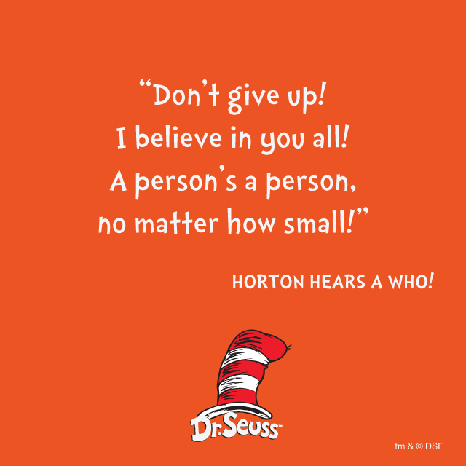

Happy Friday thoughts for the end of week 2 of Home Learning. I hope you have all had an ok week.

Mrs Filtness 