

66 Club

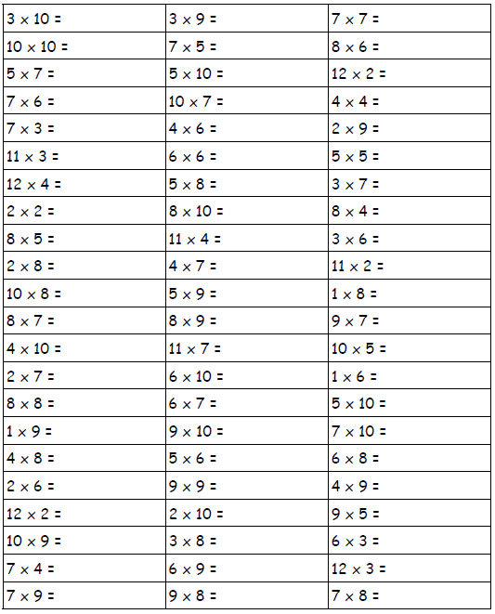Name:___________________ Date:________