Prime Area: Physical Development
- Move confidently in a range of ways, with equipment and around obstacles
- Use a pencil and hold it effectively to form recognisable letters that are correctly formed
- Handle equipment and tools effectively
- Mud and paint mixing – with hands and feet, exploring consistency with African inspired colours and pattern
- African inspired dance and movement, inspired by the topic text, The Greedy Zebra
- Manage personal needs successfully, and independently
- Exploring healthy food choices and considering the impact on oral hygiene

Prime Area: Personal, Social & Emotional Development
- Understand and respect others who may not agree with you: ‘What is your favourite animal? Why?’
- Take account of one another’s ideas about how to organise an activity eg role-play or a focused learning task
- Develop self-awareness of their own feelings in different scenarios and show sensitivity to the feelings of others
- Select own resources needed for a given activity and know how to seek support from a variety of sources, if needed
- WWO – giving and receiving feedback

EYFS Framework – 3 Prime Areas of Learning and 4 specific areas underpinned by four key themes: A unique child; Positive Relationships; Enabling Environments; Learning and Development

Prime Area: Communication & Language
- Respond to what they hear with relevant comments and/or questions, explaining their thoughts and opinions
- Answer ‘how’ and ‘why’ questions in response to stories, events and guessing games (eg What animal am I?)
- Follow instructions involving several ideas or actions; give similar instructions to others
- Communicate effectively in role-play scenarios (safari, market time)
- Explore key phrases in African languages eg the Maasai tribe, Kenya

Literacy: Comprehension, Word Reading and Writing
Texts:- Greedy Zebra, The Tiger Who Came to Tea, Handa’s Surprise,
One Day on Our Blue Planet, The Hunter, Meerkat Mail, Giraffes Can’t Dance, Mama Panya’s Pancakes
- Read and understand sentences using phonic knowledge to decode regular words
- Demonstrate understanding when talking with others about what they have read
- Write simple sentences, which can be read by themselves and others: create a fact file about their favourite animal/re-tell a familiar story
- Use and understand new vocabulary introduced through fiction and non-fiction texts
- Use key features of narrative and non-fiction in their own writing
- Begin to spell phonetically regular words of more than one syllable as well as many irregular but high frequency words

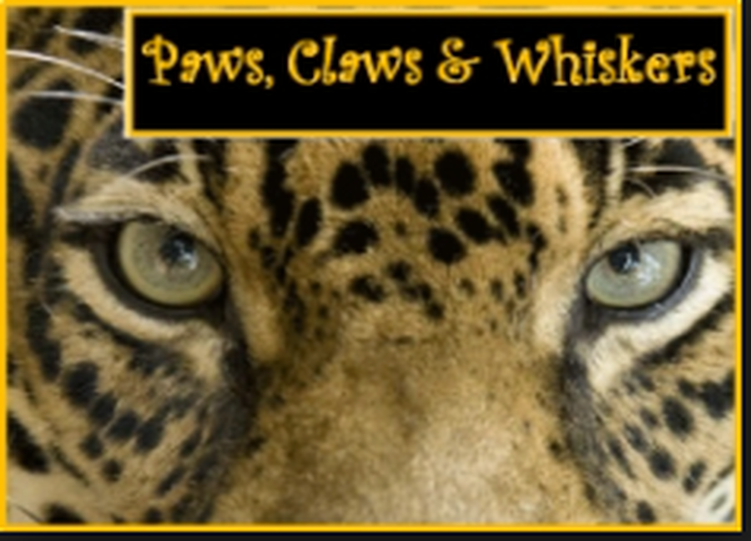
(What are the features of Africa and the animals that live there?)

Cherry Pips’ Topic Web

TERM 4 Spring 2022
EYFS Medium Term Planning, based on the characteristics of effective learning:- playing and exploring, active learning, creative and critical thinking

Maths: Number and Numerical Patterns
- Use numbers to 20 (and beyond) to solve calculations and number problems
- Identify one more/less than a given number, and number bonds to 10 (and then 20) ie 6+4, 8+2 etc
- Solve practical problems that involve combining groups of 2, 5 or 10, or sharing into equal groups
- Record and explain mathematical calculations/problem solving
- Use money at the role-play market stall: calculate totals of a variety of 1p-20p coins
- Read o’clock and half-past times
- Find halves and quarters of objects and quantities
- Explore pattern in animal skins and create our own

Understanding of the World
- Explore African safari footage; learn about the wild animals that live there, including differences and similarities
- Investigate and compare habitats, climate and landscapes, finding out through personal experience and through books
- Explore life in an African village and compare it to our local village and surrounding areas (including variations in diet)
- Begin to describe some actions within our immediate communities that help to maintain the area they live in
- Identify continents and countries of the world on a map
- Use technology to record words and phrases of other languages eg of the Maasai tribe
Expressive Arts & Design
Print making and collage to make patterns based on the natural markings of animals
African masks and carvings: make their own using clay
- Safely use and explore a variety of materials, tools and techniques, experimenting with colour, design, texture, form and function:- create patterns through printing/collage/clay, inspired by animal prints
- African inspired dance and movement:- use drums to beat out rhythms. Children to continue to explore, using upturned buckets etc.
- Talk about features of their own and others work, recognising the differences between them and the strengths of others
- Learn African call and response songs eg Kye key kule

