a
Science
- Investigating everyday materials
- Investigating the best material to make a cape for the BFG
- Looking at the diet of the different giants and discussing what a heathy diet looks like
- Designing and making heathy giant snacks

ENGLISH

- Writing stories and poems about Giants using ‘The BFG’ as a starting point
- Reading and creating our own recipes for dreams
- Learning strategies to help spell exception words
- Finding interesting words to create our own descriptions of giants
- Investigating common suffixes and prefixes and how they change the meaning of words
- Developing use of punctuation e.g. using full stops, exclamation marks and question marks
- Practicing cursive handwriting

COMPUTING
- Creating an illustration of a dream using a drawing programme
- Plotting a BFG journey on a map using a Beebot
- Investigating sound waves and recording our voices
ART and DT
- Investigating Quentin Blake's illustrative techniques – pencil sketching and water colours
- Designing and making dream catchers
- Designing different giants using descriptive work and creating clay models from our designs
Term 1 2021
Roald Dahl, The BFG
Cherry Class Year 1 and 2
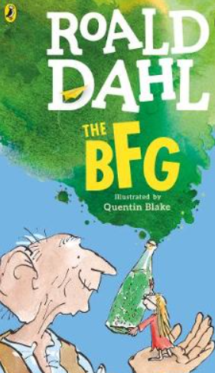
MATHS
- Investigating numbers to 100 and developing an understanding of place value
- Adding and subtracting 2 digit numbers
- Investigating 2D shapes
- Reading and writing numerals
- Learning number bonds to 20
- Exploring measurements – capacity
- Counting in multiples
- Solving problems involving number

Music
- Using the BFGs dream trumpet as inspiration, discover how trumpets create their sound.
- Create our own trumpets with the information we have found
- Listen to music involving trumpets (e.g. jazz music)
PE
- Inspired by The BFGs journeys around the World, children will put together a sequence of movements.
- Developing effective strategies when playing team games
- Developing yoga techniques
PSHEe (including WWO)
- Knowing and using names
- Using eye-contact
- Discussing new beginnings
- Exploring relationships with friends and family, respecting ourselves and others

RE
- Why is the festival of Sukkot important to Jews?
- Why am I special?

Humanities
- Using maps to locate countries and continents which the BFG travelled to.
- Investigating the life of Roald Dahl
- Researching the history of our current Royal family and the Queen.
- Making comparisons with our own personal history


