Prime Area: Physical Development
- Develop control through team games and agility activities, showing an awareness of space, self and others
- Demonstrate balance and coordination through dance and gymnastics/follow ‘Andy’s Workout’ from around the world (online)
- Use small equipment, showing a range of basic skills eg pencils, scissors
- Begin to understand the importance of physical exercise and a healthy diet for good health
- Manage own personal hygiene
- Develop stamina through ‘Golden Mile’ running

Prime Area: Personal, Social & Emotional Development
- Settle into new school community: develop friendships, and understand the need to follow agreed codes of behaviour
- Select and use activities and resources independently
- Working with Others (WWO) skills:- knowing and using names, eye contact
- Respond to significant experiences, showing a range of feelings when appropriate
- Have a developing awareness of own needs, views and feelings and show sensitivity to the needs, views and feelings of others
- Consider similarities and differences: what makes me special/what makes me, me?

EYFS Framework - 3 Prime Areas of Learning and 4 Specific Areas underpinned by four key themes: A Unique Child; Positive Relationships; Enabling Environments; Learning and Development
As part of our Growth Mindset approach we are collaborative, resilient, disciplined, imaginative and curious learners
Prime Area: Communication & Language
- Listen attentively to stories, responding with relevant comments, questions and actions: focus on ‘one question a day’ about LEAF
- Listen to and follow instructions
- Respond to ‘how’ and ‘why’ questions about own experiences
- Use language to imagine and recreate roles and experiences
- Sing simple songs from memory
- Make connections between ideas and events

Literacy: Reading and writing
- Develop phonics skills to support reading e.g linking sounds to letters
- Begin to recognise a few familiar words eg names
- Begin to demonstrate understanding when talking with others about what they have read eg consider the characters’ different perspectives in LEAF
- Experiment with mark making, sometimes ascribing meaning to the marks
- Use some clearly identifiable letters to communicate meaning
- Hold a pencil and use it effectively to form recognisable letters, developing a pre-cursive style (on going)

LEAF
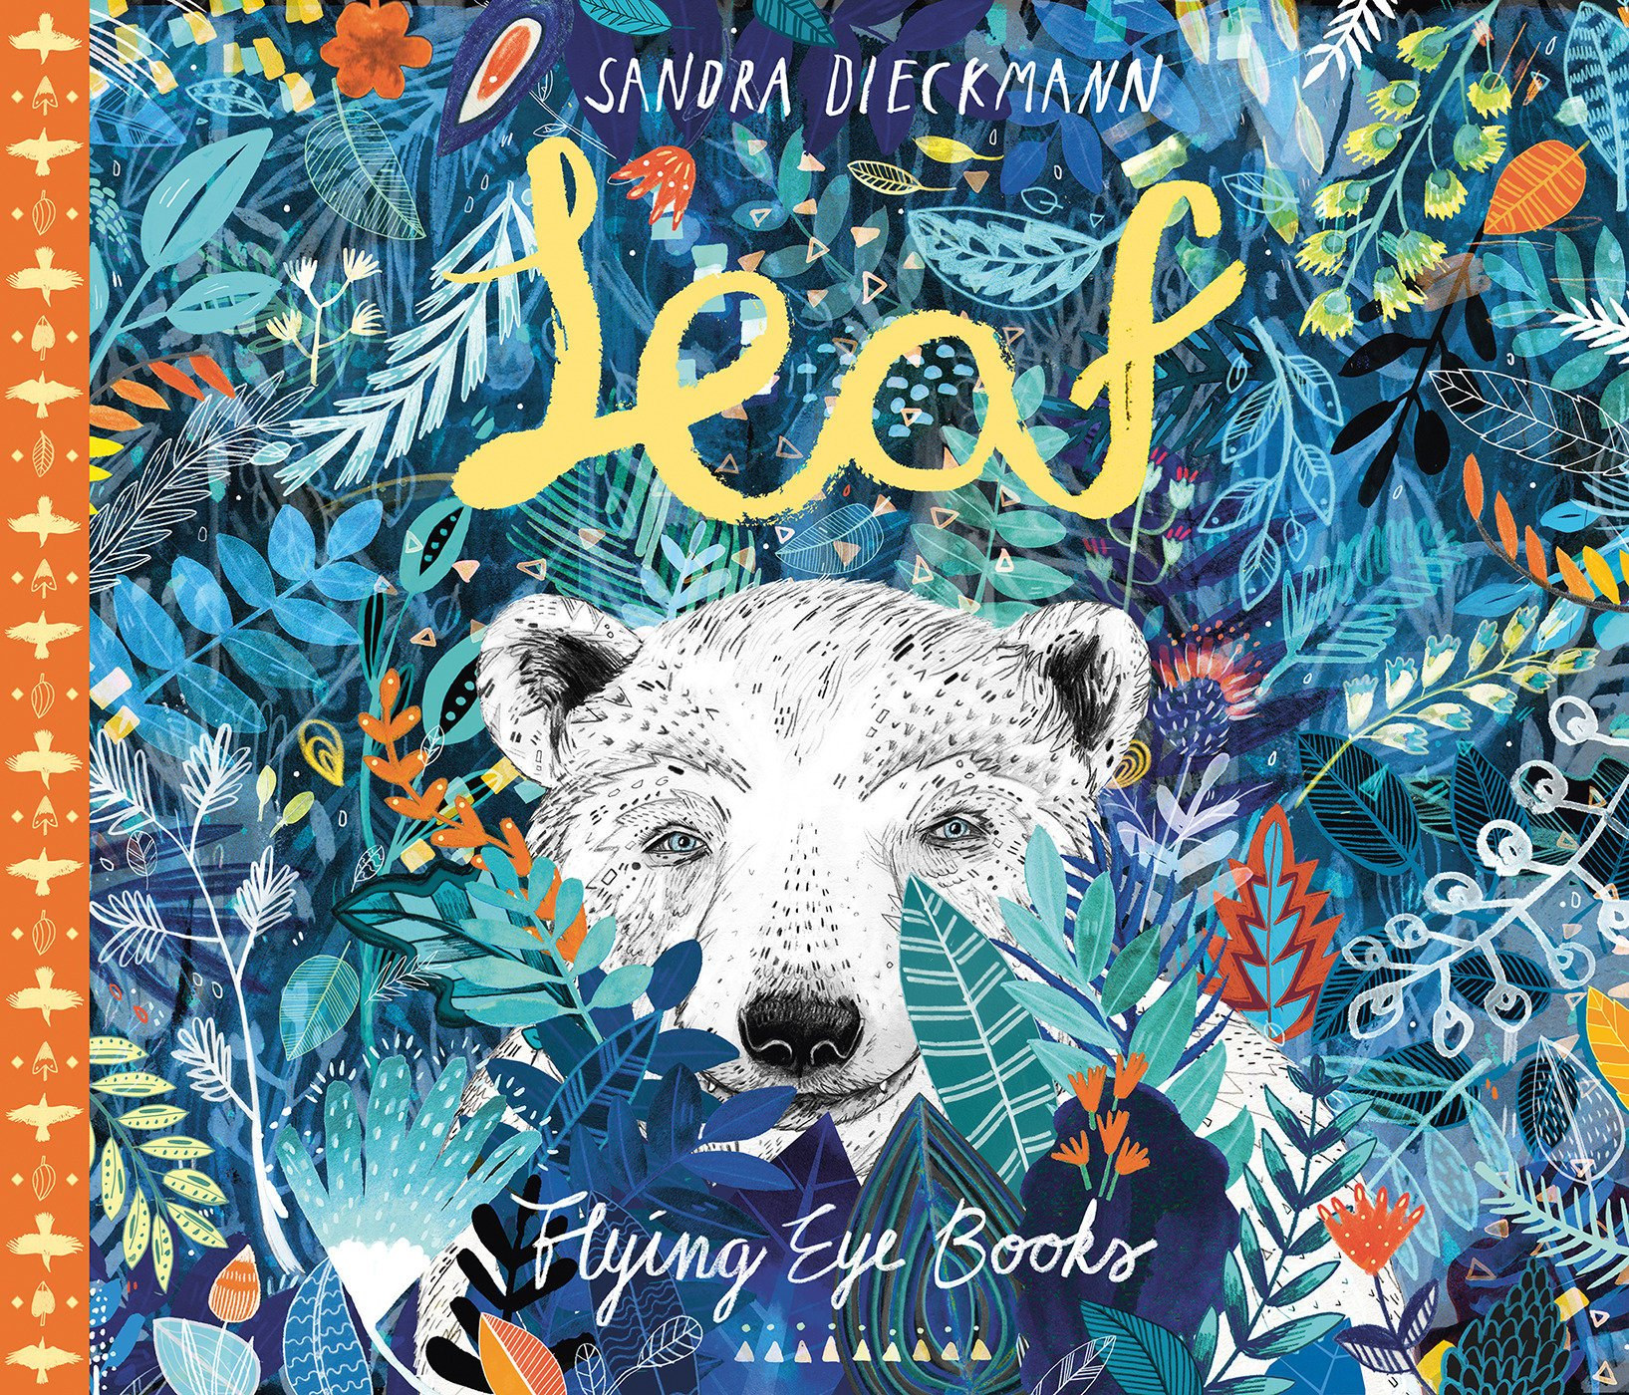

Cherry Class Pips

TERM 1 Autumn 2020
EYFS Medium Term Planning, based on the characteristics of effective learning:- playing and exploring, active learning, creative and critical thinking

Mathematics
- Explore number to 20: ordering number; comparing quantities; finding one more/less; problem solving (text ‘One is a snail, Ten is a Crab’ as inspiration)
- Sort and compare objects and discuss criteria
- Order items by length/height/weight eg animals from LEAF
- Begin to explore shapes to create patterns
- Use positional language e.g up/down; left/right through physical movement and objects
- Interpret data handling eg survey of favourite animals etc

Understanding of the World
- Ask questions about why things happen and how things work, looking closely at similarities, differences, patterns and change linked to LEAF; consider the effects of climate change
- Use maps to locate countries, continents and oceans which contain the natural habitats of the polar bear and other animals in the text
- Observe and reflect on seasonal changes
- Undertake investigations e.g what makes an object fly?; why/how does ice melt?; how are different sounds made?
- Find out about and identify the uses of everyday technology at home and school e.g how to use digital media such as cameras and iPads safely and appropriately; investigate the themes brought up in LEAF using a search engine
- Create an illustration using a drawing programme
- RE:- ‘I’m Special’

Expressive Arts & Design
- Use a variety of different media including drawing tools to create representational pictures
- Explore colour, texture, shape, form and space in two or three dimensions, inspired by the illustrations of Sandra Diekmann
- Represent ideas through design and technology to create a 3D model with wings
- Listen to and respond to a range of high quality recorded music inspired by flight (the finale of Sibelius’ 5th Symphony, Saint-Saens ‘The Swan’ from The Carnival of the Animals,); incorporate music into dance activities; consider how music can influence our mood
- Explore pulse and rhythm: repeat and create short rhythmic phrases
- Use percussion instruments in a variety of ways

