Tuesday 31st March – RE day Please read all the information carefully – the tasks for you to complete are in bold.
Stick these pictures in to the middle of a piece of paper.
- Write down any thoughts about the pictures
- What do you think they are showing?
- Where were they taken?
- Who might they be important to?
- Write any questions they have about the picture they have been given.
- Write your predictions as to what you think today’s lesson is going to be about.
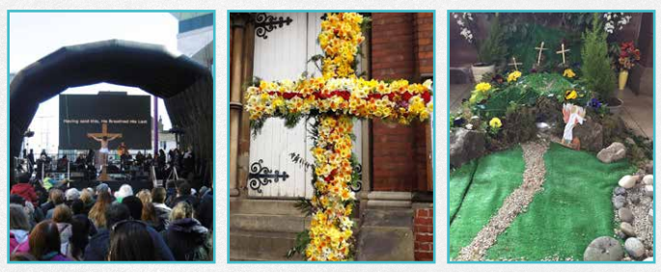
This lesson is going to teach you about the resurrection of Jesus and the different viewpoints of Christians into the importance of this event.
In your own words – write a definition of the word ‘resurrection’
Here are pictures that show the story of the resurrection of Jesus
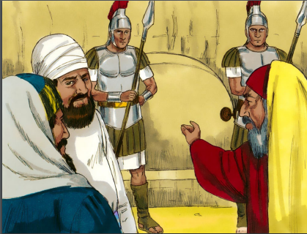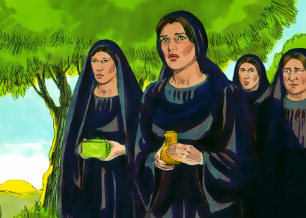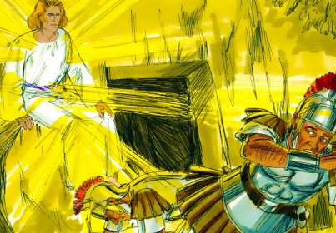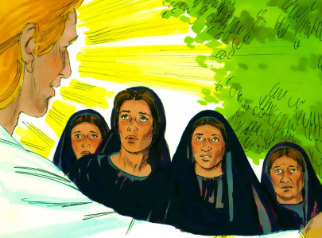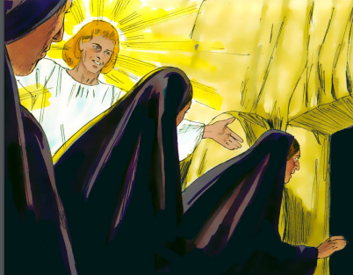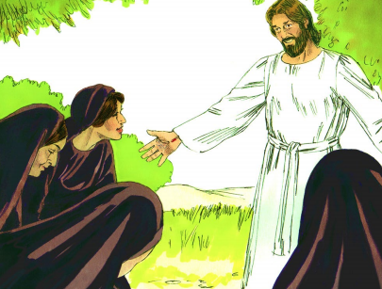
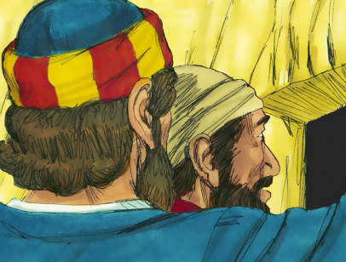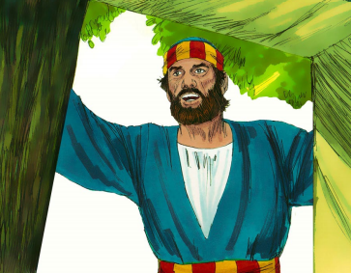

Using the pictures to support you, put these statements in order:
- Three days later, on the first day of the week, early in the morning, a group of women who were followers of Jesus set out for the tomb. Among them were Mary the mother of James, and Mary Magdalene. They were bringing spices and oils to embalm the body and wondered how they would be able to roll back the large heavy stone covering the tomb.
- The women rushed off to tell the disciples Jesus was alive. But the disciples did not believe them. Peter and John ran to the tomb to see what had happened.
- Suddenly there was a violent earthquake as an angel of the Lord came down from heaven, rolled back the stone covering the tomb entrance and sat on it. His appearance was as bright as lightning, and his clothes were white as snow. The guards were so petrified they trembled and ran off.
- On the evening that Jesus was buried, the tomb was sealed and guards were posted to keep watch over it.
- ‘Do not be afraid, for I know that you are looking for Jesus, who was crucified,’ the angel said. ‘He is not here, He has risen, just as He said. Come and see the place where He lay.
- ‘Now go quickly and tell his disciples, “He has risen from the dead and is going ahead of you into Galilee.”’
- He also saw the strips of linen lying there, and the cloth that had been wrapped round Jesus’ head. The cloth was still lying in its place, separate from the linen. Peter was puzzled and wondered what had happened. He did not understand from the scriptures that it was God’s plan for Jesus, the Messiah, to suffer, die and then be raised to life.
- When the women arrived at the tomb they noticed the large stone covering the entrance had been rolled back. As they entered the tomb they saw the angel and were alarmed.
- Suddenly Jesus met them. ‘Greetings,’ He said. They came closer to him, clasped His feet and worshipped Him. ‘Do not be afraid,’ Jesus told them. ‘Go and tell my brothers to go to Galilee and they will see me there.’
- John arrived first and stared into the empty tomb. He saw strips of linen lying there but did not go in. Simon Peter caught up and went straight into the tomb

Watch the video – in this table, write down the arguments for and against whether or not the resurrection of Jesus took place.
http://request.org.uk/jesus/death-and-resurrection/what-happened-to-the-body/

Arguments for | Arguments against

Read the information sheet that includes the different viewpoints of the resurrection from the Bible and complete the resurrection activity sheet.

Finally, answer this question in your own words:
What do you think the importance of the resurrection is for Christians?

