I like reading and writing | Write a poem about an African animal.  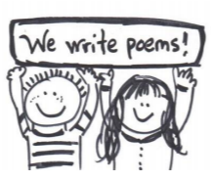 | Write a fact file about a famous African person.
I enjoy maths | Explore patterns. Using items that you can find outside, create a pattern. Try leaf, stone, leaf, stone, etc. or stick, stone, grass, stick, stone, grass. Have a go at designing then making or drawing (in colour) a pattern based on Maasai beadwork. |  |  | Swahili is officially spoken along the east coast of Africa. It is said to be the easiest African language for an English speaker to learn. This is because the words are read out just the way they are written. Learn to count to 10 in Swahili. The numbers in Swahili: 0 = Sifuri 1 = Moja 2 = Mbili 3 = Tatu 4 = Nne 5 = Tano 6 = Sita 7 = Saba 8 = Nane 9 = Tisa 10 = Kumi. Watch https://www.youtube.com /watch?v=tvr1jalGmcs to help you. How easy was it? Demonstrate your skills in class. We cannot wait to hear you count to 10 in Swahili!
I like researching and finding things out. | 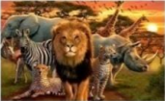  Research and write some facts about your favourite African animal. Which animal have you chosen to research? You can choose more than one if you wish. Where in Africa do they live? What do they eat? How big do they grow to? What are their babies or cubs called? Include some pictures. |  | Find out about how your school compares to a school in rural Africa. Use books and the Internet (remember our online safety rules!) How does your building compare to a school in Africa? Do the teachers use a whiteboard or another surface to write on? How are their school dinners prepared? What is the same? What is different? What are their toilets like? Do they have access to water to wash their hands after using the toilet?
I like to make things and be creative. | Watch African dances and try to recreate one, or make up one of your own! Can you perform it to your family…your teacher…the class? Or teach it to a friend!
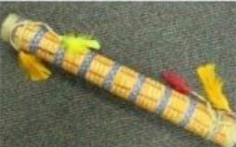
Can you make a rain stick? In traditional African culture, a rain stick is a ritualistic device used to call for rain in rain-making ceremonies. This is to avoid drought. The sound it makes is said to represent the falling of rain. Can you make your own rain stick?

I like to draw and paint. | 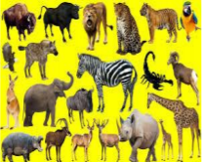  Draw an African animal. |  |  | 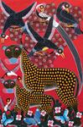  Recreate a painting in the style of an African artist such as Edward Saidi Tingtinga.
Year 1 and 2 Cherry Class Homework Grid – Long walk to freedom Term 2 2020 Each week you should: complete a quality piece of homework from the grid below, read regularly to an adult and practise key instant recall number facts (little and often is best). Please send in a message to me via eSchools Academy or attach it to an e-mail. Homework sharing is on a Tuesday Afternoon

